Generic Blank Game Design Document (GDD)

Your Game Logo

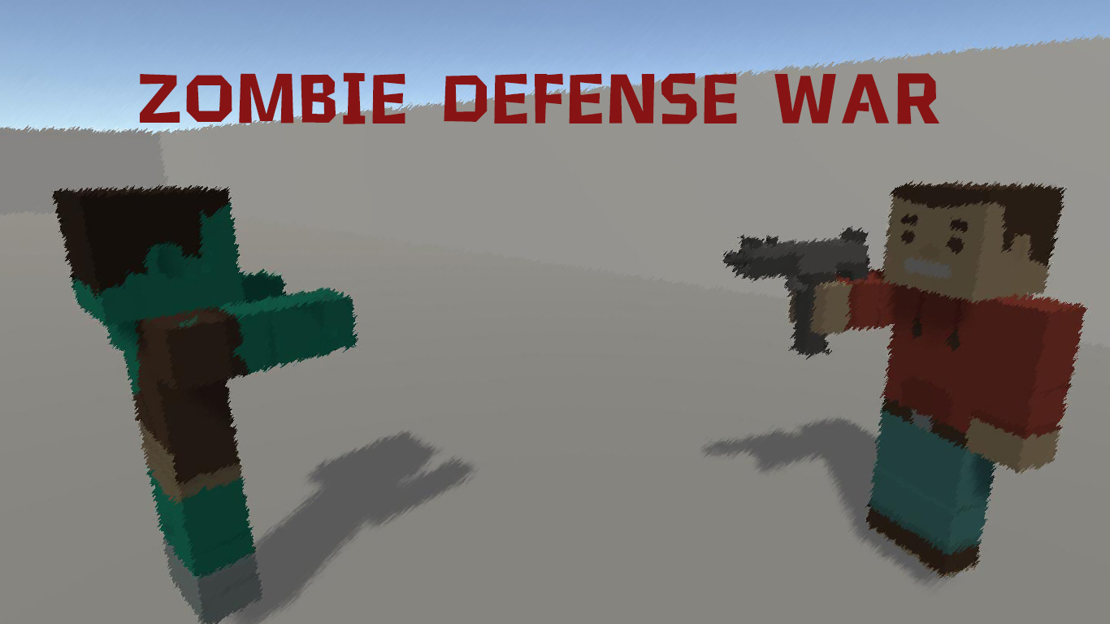

Here

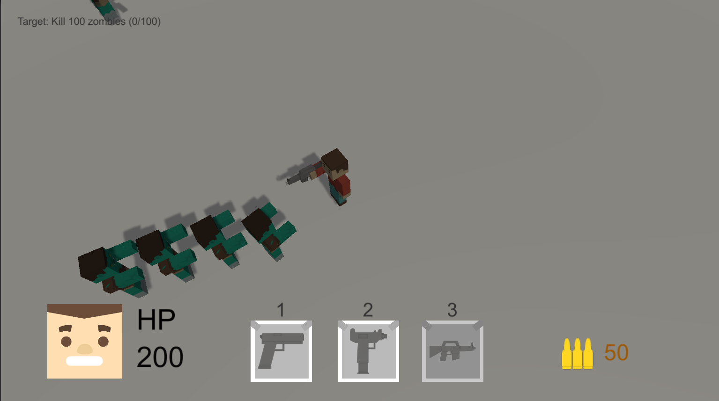

***‘Defend the zombies and try to survive’*** - AAA GAME

This page: Table of Contents and Team Member Listing

|  |  |  |
| --- | --- | --- |
| Table of Contents  [1 Game Overview](https://n-xovwktmtjsnaxyc2mwes2xu7pohqedmdm6zjw5q-2lu-script.googleusercontent.com/userCodeAppPanel)  [2 High Concept](https://n-xovwktmtjsnaxyc2mwes2xu7pohqedmdm6zjw5q-2lu-script.googleusercontent.com/userCodeAppPanel)  [3 Unique Selling Points](https://n-xovwktmtjsnaxyc2mwes2xu7pohqedmdm6zjw5q-2lu-script.googleusercontent.com/userCodeAppPanel)  [3.1 Inventory system](https://n-xovwktmtjsnaxyc2mwes2xu7pohqedmdm6zjw5q-2lu-script.googleusercontent.com/userCodeAppPanel)  [3.2 Gamification](https://n-xovwktmtjsnaxyc2mwes2xu7pohqedmdm6zjw5q-2lu-script.googleusercontent.com/userCodeAppPanel)  [3.3 Quest System](https://n-xovwktmtjsnaxyc2mwes2xu7pohqedmdm6zjw5q-2lu-script.googleusercontent.com/userCodeAppPanel)  [4 Platform Minimum Requirements](https://n-xovwktmtjsnaxyc2mwes2xu7pohqedmdm6zjw5q-2lu-script.googleusercontent.com/userCodeAppPanel)  [5 Competitors / Similar Titles](https://n-xovwktmtjsnaxyc2mwes2xu7pohqedmdm6zjw5q-2lu-script.googleusercontent.com/userCodeAppPanel)  [6 Synopsis](https://n-xovwktmtjsnaxyc2mwes2xu7pohqedmdm6zjw5q-2lu-script.googleusercontent.com/userCodeAppPanel)  [7 Game Objectives](https://n-xovwktmtjsnaxyc2mwes2xu7pohqedmdm6zjw5q-2lu-script.googleusercontent.com/userCodeAppPanel)  [8 Game Rules](https://n-xovwktmtjsnaxyc2mwes2xu7pohqedmdm6zjw5q-2lu-script.googleusercontent.com/userCodeAppPanel)  [9 Game Structure](https://n-xovwktmtjsnaxyc2mwes2xu7pohqedmdm6zjw5q-2lu-script.googleusercontent.com/userCodeAppPanel)  [10 Game Play](https://n-xovwktmtjsnaxyc2mwes2xu7pohqedmdm6zjw5q-2lu-script.googleusercontent.com/userCodeAppPanel)  [10.1 Game Controls](https://n-xovwktmtjsnaxyc2mwes2xu7pohqedmdm6zjw5q-2lu-script.googleusercontent.com/userCodeAppPanel)  [10.2 Game Camera](https://n-xovwktmtjsnaxyc2mwes2xu7pohqedmdm6zjw5q-2lu-script.googleusercontent.com/userCodeAppPanel)  [10.2.1 HUD](https://n-xovwktmtjsnaxyc2mwes2xu7pohqedmdm6zjw5q-2lu-script.googleusercontent.com/userCodeAppPanel)  [10.2.2 Maps](https://n-xovwktmtjsnaxyc2mwes2xu7pohqedmdm6zjw5q-2lu-script.googleusercontent.com/userCodeAppPanel)  [11 Players](https://n-xovwktmtjsnaxyc2mwes2xu7pohqedmdm6zjw5q-2lu-script.googleusercontent.com/userCodeAppPanel)  [11.1 Characters](https://n-xovwktmtjsnaxyc2mwes2xu7pohqedmdm6zjw5q-2lu-script.googleusercontent.com/userCodeAppPanel)  [11.2 Weapons](https://n-xovwktmtjsnaxyc2mwes2xu7pohqedmdm6zjw5q-2lu-script.googleusercontent.com/userCodeAppPanel)  [12 NPC](https://n-xovwktmtjsnaxyc2mwes2xu7pohqedmdm6zjw5q-2lu-script.googleusercontent.com/userCodeAppPanel)  [12.1 Enemies](https://n-xovwktmtjsnaxyc2mwes2xu7pohqedmdm6zjw5q-2lu-script.googleusercontent.com/userCodeAppPanel)  [12.1.1 Enemy Model](https://n-xovwktmtjsnaxyc2mwes2xu7pohqedmdm6zjw5q-2lu-script.googleusercontent.com/userCodeAppPanel)  [12.1.2 Enemy Spawn Points](https://n-xovwktmtjsnaxyc2mwes2xu7pohqedmdm6zjw5q-2lu-script.googleusercontent.com/userCodeAppPanel)  [13 Bibliography](https://n-xovwktmtjsnaxyc2mwes2xu7pohqedmdm6zjw5q-2lu-script.googleusercontent.com/userCodeAppPanel)  [14 Wish List](https://n-xovwktmtjsnaxyc2mwes2xu7pohqedmdm6zjw5q-2lu-script.googleusercontent.com/userCodeAppPanel)   |  | | --- | |  | | Game Development Team Members    PRODUCER  AAA GAME    PRODUCTION MANAGER  AAA GAME    PRODUCTION COORDINATOR  AAA GAME  GAME DESIGNERS  AAA GAME  SYSTEMS/IT COORDINATOR  AAA GAME  PROGRAMMERS  AAA GAME  TECHNICAL ARTISTS  AAA GAME  AUDIO ENGINEERS  AAA GAME  UX TESTERS  AAA GAME |
|  |  |

|  |
| --- |
|  |

AAA Game : Siming Cheng, Shanshan Li , Yiliang Shi , Liaojialing He

# 1 Game Overview

Title: Zombie defense war

Platform: PC Standalone + iOS & Android, VR, XBox, Switch,

Genre: Shooting Game

Rating: (10+) ESRB

Target: Casual gamer (aging from 12 - 30)

Release date: February, 2021

Publisher: Your Company Name

Description: This is a zombie defense game, you will find a way to defend as long as possible in the limited bullets and unlimited supplies, and survive. There are many weapons here. Each weapon has different power, cooling time and repulsion effect. Use these weapons reasonably to kill zombies.

# 2 High Concept

The idea of this game comes from some zombie defense games, some area sizes, and then give you different weapons to defend. At the same time, the model model of the characters is very similar to the characters in minecraft, which is a block structure. At the same time, the animation of the game character movement is very consistent with it.

# 3 Unique Selling Points

The selling point of this game is that you need to survive in a lot of zombies, and then you can use different weapons to match different effects. You say that the attributes of weapons are different, and they all have their own roles. After you kill zombies, zombies will also drop some ammunition. In killing zombies and avoiding zombies, it is very difficult to test the operability of players.

## 3.1 Inventory system

The game has an inventory system, you can have different guns, each gun has its own bullets, each gun has its own attributes. You can pick up ammunition from the ground to fill your gun. You can switch guns by pressing the button.

## 3.2 Gamification

This game has a complete gamification, the whole game zombies will react according to your attack, your characters will also respond to the zombie attack. The whole game has complete rules and a way to end the game.

## 3.3 Quest System

The game also has a quest system, the system task will be displayed in your upper left corner, when you have completed the task, it will display the progress of your completion in real time.

# 4 Platform Minimum Requirements

OS: Windows Vista/Windows 7/Windows 8

Processor: 1.7+ GHz or better

Memory: 1 GB RAM

Graphics: Radeon HD5450 or better; 256 MB or higher

DirectX: Version 9.0c

Network: Broadband Internet connection

Storage: 750 MB available space

Sound Card: 100% DirectX9.0c compatible sound card and drivers

# 5 Competitors / Similar Titles

The Similar zombie defense game.

# 6 Synopsis

In the game, you will have a target to kill zombies, which you can accomplish. The completion of this goal will be displayed in the upper left corner of the game in real time. Then the whole game can be around this, you can kill zombies, you can practice, but then to achieve your goal.

# 7 Game Objectives

The goal of the game is to survive, but some have another goal, which is to kill 100 zombies. This target will be displayed on the UI at the top left in real time. You can see it in real time. Then every time you kill a zombie, the target will be updated. Until you kill 100 zombies, the target will show that it has been completed.

# 8 Game Rules

The rules of the game are very simple, you need to use your gun to kill zombies, press the left mouse button can shoot bullets, and then you can switch your weapons by pressing the number key 1 2 3. When the zombie touches you, you will hurt hp, when your hp reaches 0, the game is over.

# 9 Game Structure

The whole game structure is composed of several parts. One part is to control the game process, including zombies, survival, and the production of items. The other structure is character structure control, character movement, and character attack. The third structure is weapon structure, which controls the attack of weapons and bullets. The fourth structure is zombies, the movement of zombies and the targets of zombies.

# 10 Game Play

## 10.1 Game Controls

Wasd for moving

Mouce left button to fire.

Key 1, 2, 3 to swich your weapon.

## 10.2 Game Camera

### 10.2.1 HUD

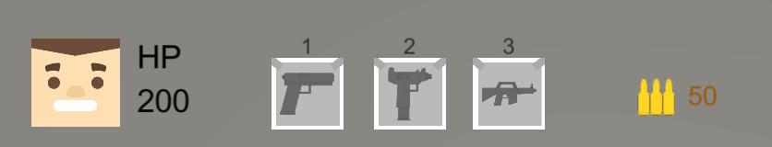

Hp, weapons, ammos

### 10.2.2 Maps

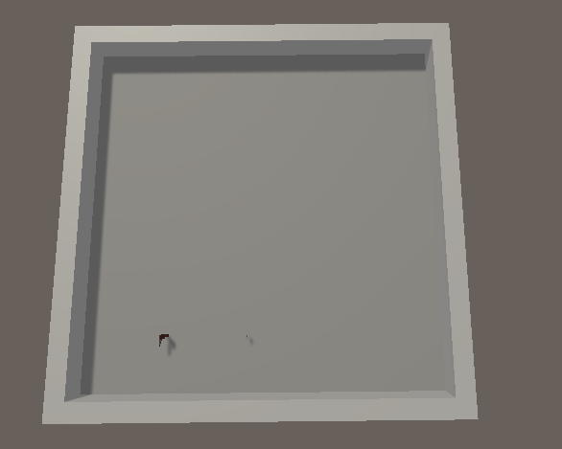

# 11 Players

## 11.1 Characters

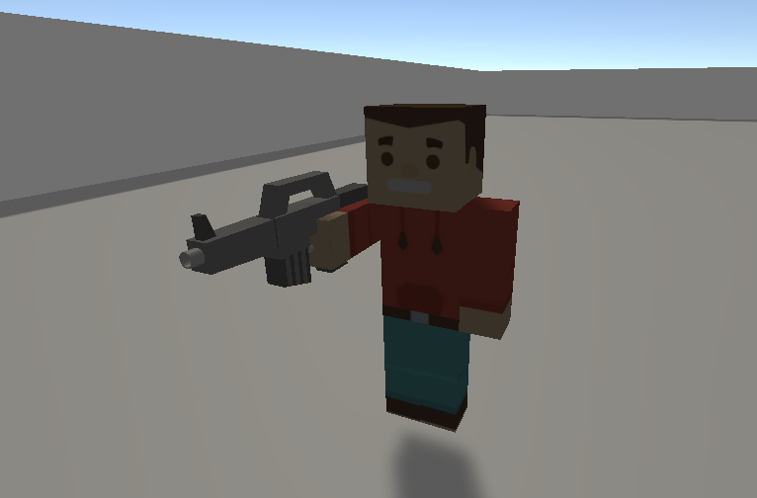

This is the character we designed.

## 11.2 Weapons

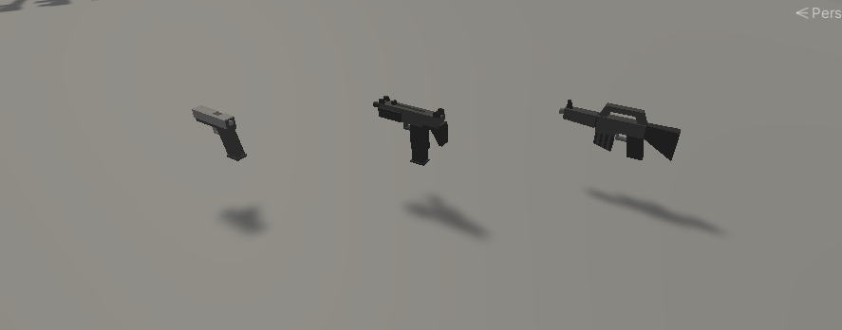

Handgun: Basic, slow fire weapon

Uzi: low damage, high firing rate weapon

Machinegun: Very powerful weapon

# 12 NPC

## 12.1 Enemies

### 12.1.1 Enemy Model

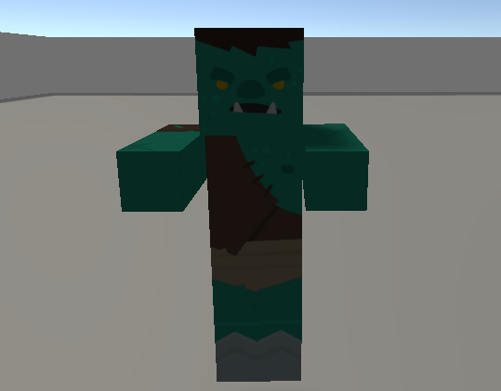

### 12.1.2 Enemy Spawn Points

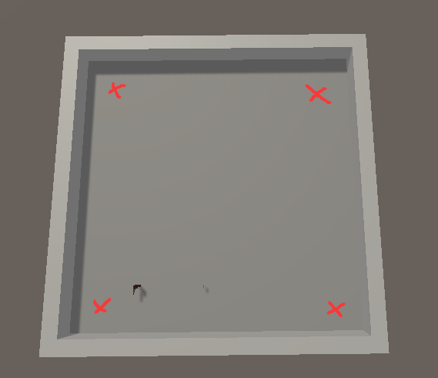

# 13 Bibliography

characters model&texture by kenney: https://kenney.nl/assets/blocky-characters

face textures by kenney: https://kenney.nl/assets/blocky-characters

weapons model&texture by kenney: https://kenney.nl/assets/weapon-pack

gunshot sound by KuraiWolf: https://opengameart.org/content/light-machine-gun

zombie sound by Catalin Pavel: https://opengameart.org/content/zombie-sound

bgm by Macro: https://opengameart.org/content/zombie-garden

bg, bullets, Weaponsolt by https://opengameart.org/content/zombie-garden

Animations by AAA game

Program by AAA game

# 14 Scripts

Menu.cs : Provides the function to exit the game.

LoadScene.cs : Provides the function to load scenes.

GameManager.cs : Spawns zombies and creates items when zombie die, also keeps the score

CameraFollow.cs : Controls the camera to follow player.

Player.cs : Player Control & Weapon Choose

Weapon.cs : A class to store the weapon infos, has a function to shoot bullet.

Bullet.cs : Controls the movement of bullet, Judge whether to hit the enemy.

Zombie.cs : Controls the movement and attack of zombie.

VolumeSetting.cs: Store the setting of volume.

# 15 Wish List

There are a lot of things to do here, such as increasing the types of weapons, increasing the special effects and sound effects of weapons, and changing bombs. Increasing the types of zombies and increasing the difficulty will make the game more challenging. We also thought that we could add new maps and new ways of playing. We can also add new characters. Each character has different effects and characteristics. Each character has its own unique function, different hp and different moving speed.